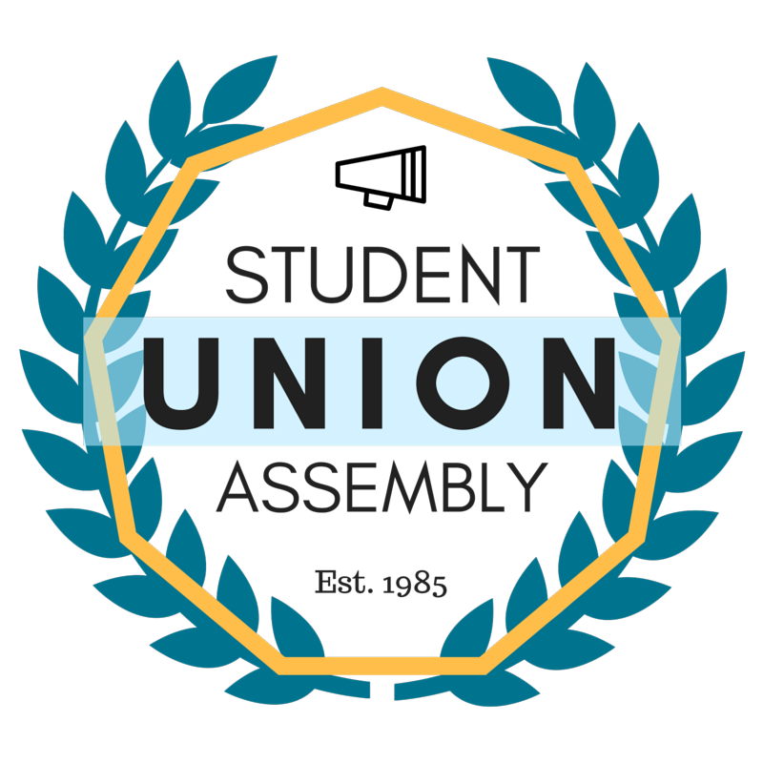
Student Union Assembly
Monthly Report
________________________________________________________________________________
SUA Mailstop: SOAR, 1156 High Street, Santa Cruz CA 95064 • P: 831.459.4838
suapres@ucsc.edu • sua.ucsc.edu
Under My duties as Vice President of Diversity and Inclusion of the Student Union Assembly and Article III Section A Subsection 6(l) of the SUA Constitution, I present my August 2016 monthly report and evaluation to the Assembly. I will outline all of my events, logistical planning, activities and constructive criticism with areas of improvement in hopes of providing a detailed account in the month’s report.

Ongoing and Completed Tasks
Meeting with Sarah Latham
Met with V.C. Sarah Latham to discuss matters relating to Trailer Park Transitions that will be occurring over the summer.
Meeting w/ Special Committee on Athletics Chair
Met with Xavier Prochaska to discuss plans moving forward with the Committee.
S.O.C.C. 2016
Have booked hotels at the Irvine Marriot and am following up on buses.
Campus Diversity Officer Search
Have attended all but one Campus Diversity Officer Interview and Presentation, most were very good candidates.
Opers Fest
Tabled at Opers Fest to Recruit for SUA
MLK Convocation
Attended meeting for MLK Convocation Planning committee
SUA Open House
Attended and Hosted SUA Open House for Recruitment
Police Chief Meeting
Met with Chief Nader to Discuss Events between SUA and the students body along with other projects.
VC IT Search Committee
Attended meeting for VC IT search committee.
C.A.A.D.
Attended first Committee on Affirmative Action and Diversity Meeting, very nice group of people.
S.C.A.
Attended first special committee on athletics and continue to attend weekly.
SACNAS
Met with SACNAS Leadership to discuss projects for this quarter and bringing students from local schools to UCSC.
Feedback
The SUA as a whole is undergoing transitions, we should pay very close attention to our ability to be affective in our goals to represent the student body. Some officers should also be more respectful of eachother.

